# Exercises: Entity Relations

This document defines the **exercise assignments** for the [Databases Advanced - Entity Framework course @ SoftUni](https://softuni.bg/trainings/4540/entity-framework-core-june-2024)  
You can check your solutions in [Judge](https://judge.softuni.org/Contests/3918/Entity-Relations)

## Student System

Your task is to create a database for the **StudentSystem**, using the **EF Core Code First** approach. It should look like this:

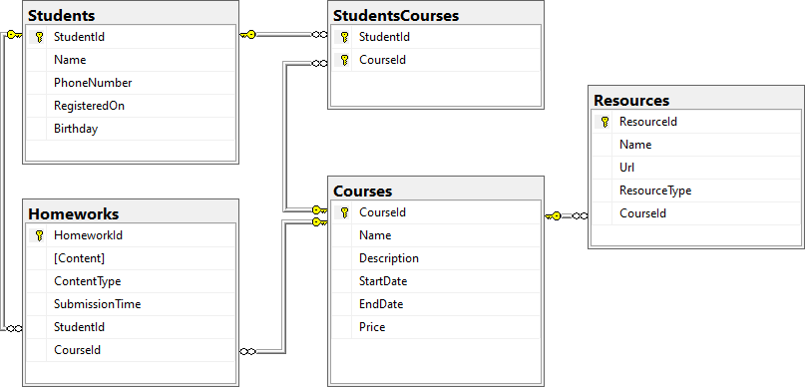

### Constraints

Your **namespaces** should be:

* P01_StudentSystem – for your **Startup** class, if you have one
* P01_StudentSystem.Data – for your **DbContext**
* P01_StudentSystem.Data.Models – for your models

Your **models** should be:

* StudentSystemContext – your **DbContext**
* Student
  + **StudentId**
  + **Name** – up to 100 characters, unicode
  + **PhoneNumber** – exactly 10 characters, not unicode, not required
  + **RegisteredOn**
  + **Birthday** – not required
* Course
  + **CourseId**
  + **Name** – up to 80 characters, unicode
  + **Description** – unicode, not required
  + **StartDate**
  + **EndDate**
  + **Price**
* Resource
  + **ResourceId**
  + **Name** – up to 50 characters, unicode
  + **Url** – not unicode
  + **ResourceType** – **enum**, can be **Video**, **Presentation**, **Document** or **Other**
  + **CourseId**
* Homework
  + **HomeworkId**
  + **Content** – **string**, linking to a file, not unicode
  + **ContentType** - **enum**, can be **Application**, **Pdf** or **Zip**
  + **SubmissionTime**
  + **StudentId**
  + **CourseId**
* StudentCourse – **mapping** between **Students** and **Courses**

Table relations:

* **One student** can have **many Courses**
* **One student** canhave **many Homeworks**
* **One course** can have **many Students**
* **One course** can have **many Resources**
* **One course** can have **many Homeworks**

You will need a constructor, accepting **DbContextOptions** to test your solution in **Judge**!

## Football Betting

Your task is to create a database for a **FootballBookmakerSystem**, using the **Code First** approach. It should look like this:



### Constraints

Your **namespaces** should be:

* P02_FootballBetting – for your **Startup** class, if you have one
* P02_FootballBetting.Data – for your **DbContext**
* P02_FootballBetting.Data.Models – for your models

Your models should be:

* **FootballBettingContext** – your DbContext
* **Team** – **TeamId**, **Name**, **LogoUrl**, **Initials** (JUV, LIV, ARS…), **Budget**, **PrimaryKitColorId**, **SecondaryKitColorId**, **TownId**
* **Color** – **ColorId**, **Name**
* **Town** – **TownId**, **Name**, **CountryId**
* **Country** – **CountryId**, **Name**
* **Player** – **PlayerId**, **Name**, **SquadNumber**, **IsInjured**, **PositionId** , **TeamId**, **TownId**
* **Position** – **PositionId**, **Name**
* **PlayerStatistic** – **GameId**, **PlayerId**, **ScoredGoals**, **Assists**, **MinutesPlayed**
* **Game** – **GameId**, **HomeTeamId**, **AwayTeamId**, **HomeTeamGoals**, **AwayTeamGoals**, **HomeTeamBetRate**, **AwayTeamBetRate**, **DrawBetRate**, **DateTime**, **Result**
* **Bet** – **BetId**, **Amount**, **Prediction**, **DateTime**, **UserId**, **GameId**
* **User** – **UserId**, **Username**, **Name**, **Password**, **Email**, **Balance**

Table relationships:

* **A Team** has one **PrimaryKitColor** and one **SecondaryKitColor**
* **A Color** has **many PrimaryKitTeams** and **many SecondaryKitTeams**
* **A Team** residents in one **Town**
* **A Town** can host **several** **Teams**
* **A Game** has one **HomeTeam** and one **AwayTeam** and a **Team** can have **many** **HomeGames** and **many** **AwayGames**
* **A Town** can be placed in **one** **Country** and a **Country** can have many **Towns**
* **A Player** can play for **one** **Team** and **one** **Team** can have many **Players**
* **A Player** can play at one **Position** and one **Position** can be played by **many** **Players**
* **One** **Player** can play in **many** **Games** and in each **Game**, **many** **Players** take part (both collections must be named **PlayersStatistics**)
* **Many** **Bets** can be placed on **one** **Game**, but **a** **Bet** can be only on **one** **Game**
* Each bet for given game must have **Prediction** result
* **A Bet** can be placed by only **one** **User** and one **User** can place many **Bets**

Separate the **models**, **data** and **client** into **different layers** (projects).